**CHAPTER 1**

**INTRODUCTION**

* 1. **Overview**

Cricket is a bat-and-ball game played between two teams of eleven players each on a cricket field, at the centre of which is a rectangular 22-yard-long pitch with a target called the wicket (a set of three wooden stumps topped by two bails) at each end. Each phase of play is called an innings during which one team bats, attempting to score as many runs as possible, whilst their opponents field. Depending on the type of match, the teams have one or two innings apiece and, when the first innings ends, the teams swap roles for the next innings. Except in matches which result in a draw, the winning team is the one that scores the most runs, including any extras gained.

Scoring in cricket matches involves two elements – the number of runs scored and the number of wickets lost by each team. The scorer is someone appointed to record all runs scored, all wickets taken and, where appropriate, the number of overs bowled. In professional games, in compliance with the Laws of Cricket, two scorers are appointed, most often one provided by each team.

**1.1.1 Problem statement**

A scorer in a cricket match has to update the score of the batsmen, bowler and team after each delivery and also keep track of the extras and the current bowler, batsmen in strike, the batsmen getting out, change in bowler, target, number of overs, over limit of each bowler and many such aspects of the game have to be monitored very precisely.

**1.1.2 The solution**

The solution for the above problem defined is that the scorer can use the web application which updates all scores on a single button click instead of the traditional score sheets.

* 1. **Existing system**

In the existing system, everything is done by a manual process. The scorer has to write everything in some particular cells of a sheet with rows and columns and maintain it like a registrar.

**Drawbacks & Limitations of existing system:**

* Time Consuming.
* It is very confusing since scores have to be updated in almost three to four columns after each legal or illegal delivery.
* Difficult to preserve details of old matches.
* Cannot have a summarized view.
* Tallying the scores of bowler, batsmen and the team is a hectic job and most of the times it doesn’t tally.
* Wastage of paper.
  1. **Proposed system**

To avoid the limitations of the existing manual system, we are coming up with a webpage application which helps scorers update runs, balls and other details of both batsmen and bowler and also the team score in one click of a button provided as a front end tool for the users. The user also can view the match details of current match and also old matches.

**1.4 Advantages**

* A scorer can update all scores of team, batsmen and bowler in a single click of a button.
* Saves time and paper

**CHAPTER 2**

**SOFTWARE REQUIREMENT SPECIFICATIONS**

**2.1 System Requirements**

•**Hardware Requirements:**

1. PROCESSOR: Pentium 4 and higher (1.2GHZ and higher)
2. RAM: 2GB and higher
3. HARD DISK: 20GB or higher.
4. Monitor: 15”CRT or LCD monitor
5. Keyboard: normal
6. Mouse: compatible mouse

•**Software Requirements:**

1. Operating system: Windows XP/7.
2. Notepad or Notepad++
3. XAMPP

**2.2 SOFTWARE INTERFACE:**

1. Front End Client - The online interface is built using CSS, PHP and HTML.
2. Back End – MySQL database

**2.2.1 Software description**

**XAMPP**  is a free and open source cross-platform web server solution stack package developed by Apache Friends, consisting mainly of the Apache HTTP Server, MariaDB database, and interpreters for scripts written in the PHP and Perl programming languages.XAMPP stands for Cross-Platform (X), Apache (A), MariaDB (M), PHP (P) and Perl (P). It is a simple, lightweight Apache distribution that makes it extremely easy for developers to create a local web server for testing and deployment purposes. Everything needed to set up a web server – server application (Apache), database (MariaDB), and scripting language (PHP) – is included in an extractable file.

|  |  |
| --- | --- |
| Developers | Apache Friends |
| Repository | www.apachefriends.org |
| Written in | Various languages |
| Operating System | Cross-platform; Linux; Windows; Solaris; macOS |

**MySQL (XAMPP):**

Is an open source relational database management system (RDBMS) which is integrated in the XAMPP web server.

**CHAPTER 3**

**SYSTEM ANALYSIS AND DESIGN**

**3.1 System analysis**

System analysis is a detailed study of the various operations performed by a system and their relationships within and outside the system. It is a systematic technique that defines goals and objectives. The goal of system development is to deliver the system in line with the user’s requirement, and analysis of the system plays an important role. One of the main aspects of analysis is defining the boundaries of the system. System study has been conducted with the following objectives:

* 1. Identify user’s need.
  2. Evaluate the system concept for feasibility.
  3. Perform economical and technical analysis.
  4. Allocate functions to hardware, software, people, database, etc.

The various tools of structured analysis are**:**

* Entity-Relationship Diagram
* Data Flow Diagram
* Use-case Diagram

**3.2 High Level Design**

**3.2.1 System Architecture**

**S**ystem architecture is the conceptual model that defines the structure, behavior, and views of a system. An architecture description is a formal description and representation of a system, organized in a way that supports reasoning about the structures and behaviors of the system. System architecture can comprise system components, the externally visible properties of those components, the relationship (e.g. the behavior) between them. It can provide a plan from which products can be procured, and systems developed, that will work to get implement the overall system.

**3.2.2 Data flow diagram (DFD)**

A data flow diagram (DFD) is a graphical representation of the "flow" of data through an information system, modeling its process aspects. Often they are a preliminary step used to create an overview of the system which can later be elaborated. DFDs can also be used for the visualization of data processing (structured design).

It is common practice to draw the context-level data flow diagram first, which shows the interaction between the system and external agents which act as data sources and data sinks. On the context diagram the system's interactions with the outside world are modeled purely in terms of data flows across the system boundary.

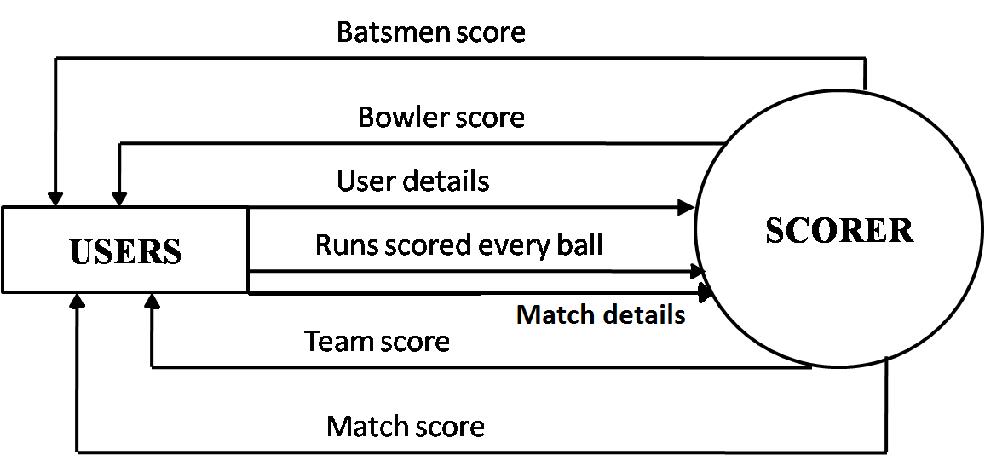

**Figure 4.2.2(a):** Level 0 DFD

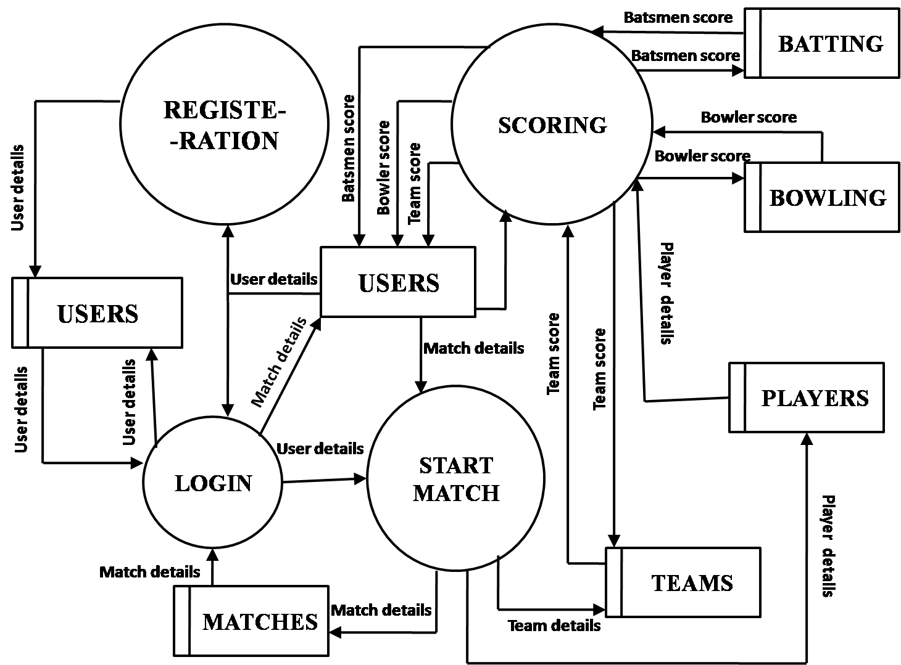

**Figure 4.2.2(b**): Level 1 DFD

**3.2.3 Use case Diagram**

Use-case diagram is a coherent piece of functionality that a system can provide by interacting with actors. In our system, all the modules are going to interact with one or the other actors (different actors could be, registered users, new users, database admin). The use case technique is used to capture a system behavioral by dealing scenario drives threads through the functional requirements. The components in a use case diagram include:

* **Use cases:** A use case describes a sequence of actions that provides something of measurable value to an actor and is drawn as a horizontal ellipse.
* **Actors:** An actor is a person, organization, or an external system that plays a role in one or more interactions with the system.
* **Associations:** Associations are shown between actors and use cases by drawing a solid line between them.

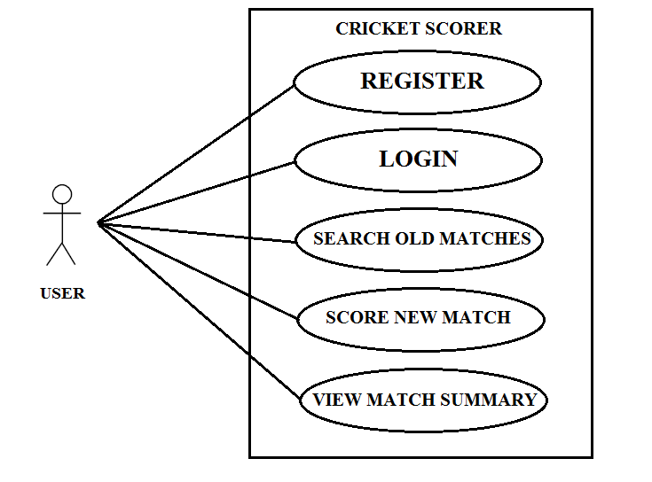

**Figure 3.3.1(a):** Use case diagram of user module

**Figure 3.3.1(b**): Use case diagram of Admin Module

**3.2.4 ER Diagram**

Entity Relationship model (ER model for short) is an abstract way to describe a database design. It usually starts with a relational database, which stores data in tables. Some of the data in these tables point to data in other tables.

Data in the table is retrieved using primary key. The primary key is the one which uniquely identifies each record in the table in relational database management system.

In ER Diagram an entity may be defined as a thing which is recognized as being capable of an independent existence and which can be uniquely identified. An entity is an abstraction from the complexities of a domain.

A relationship captures how entities are related to one another. Entity–relationship diagrams don't show single entities or single instances of relations.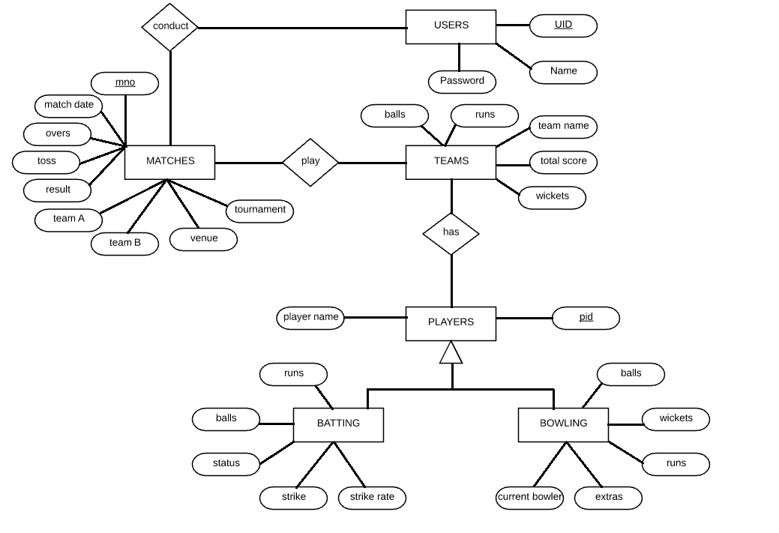

**Figure 3.4**: ER Diagram of whole system

* + 1. **Schema**

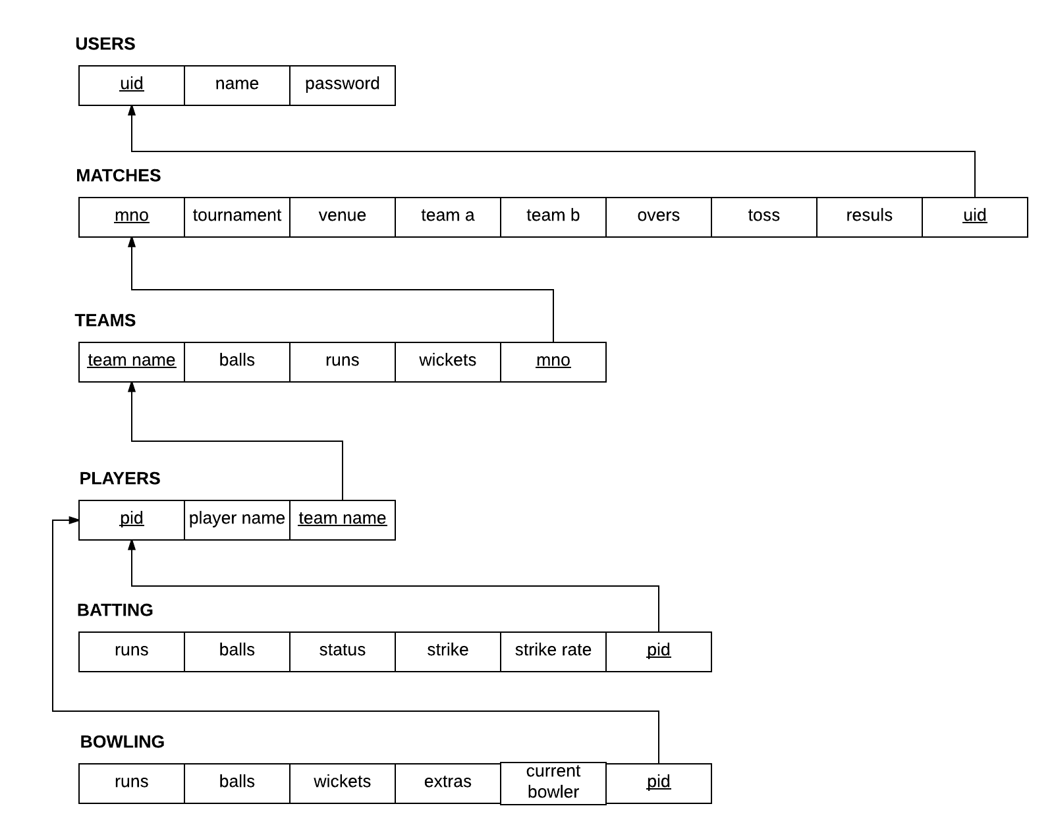

**3.2.6 Database Table Structure**

|  |  |  |
| --- | --- | --- |
| **Table name** | **Attributes** | **Primary keys** |
| Table USER | Uid(PK varchar(50),not null)  Name(varchar(50),null)  password(varchar(50),null) | uid |
| Table matches | Mno(PK int(11),not null)  Tournament(varchar(50),null)  Venue(varchar(50),null)  Team_a(varchar(50),null)  Team_b(varchar(50),null)  Date(date,null)  Uid(FK varchar(50),not null)  Toss(varchar(50),null)  Result(varchar(50),null) | mno |
| Table teams | Tname(PKvarchar(50),not null)  Runs(int(11),null)  Balls(int(11),null)  Wickets(int(11),null)  Extras(int(11),null)  Mno(FK int(11),not null) | tname |
| Table players | Pid(PK pid int(11),not null)  Pname(varchar(50),null)  Tname(FK varchar(50),null) | pid |
| Table batting | Runs(int(11),null)  Balls(int(11),null)  Status(varchar(50),null)  Strike(varchar(50),null)  Pid(FK varchar(50),null)  Strike_rate(float,null) |  |
| Table bowler | Runs(int(11),null)  Balls(int(11),null)  wickets(int(11),null)  extras(int(11),null)  Pid(FK varchar(50),null)  Current_bowler(int(11),null) |  |

**CHAPTER 4**

**DATABASE TECHNIQUES AND RESULTS**

**4.1 Normalization:**

**4.1.1 2nd NORMAL FORM:**

A relation that is in first normal form (1NF) must meet additional criteria if it is to qualify for second normal form. Specifically: a relation is in 2NF if it is in 1NF and no non-prime attribute is dependent on any proper subset of any candidate key of the relation. A non-prime attribute of a relation is an attribute that is not a part of any candidate key of the relation.

Put simply, a relation is in 2NF if it is in 1NF and every non-prime attribute of the relation is dependent on the whole of every candidate key.

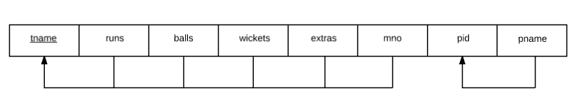

Here this relation is having multiple dependency of non primary key which violates the 2nd normal form criteria. i.e. , the non-prime attributes runs, balls, wickets, extras and mno are dependent on the candidate key tname where as the non-prime attribute pname is dependent on the candidate key pid.

To solve this and to bring the relation into 2nd normal form we break this relation into two different relations called ‘teams’ and ‘players’ as shown below.

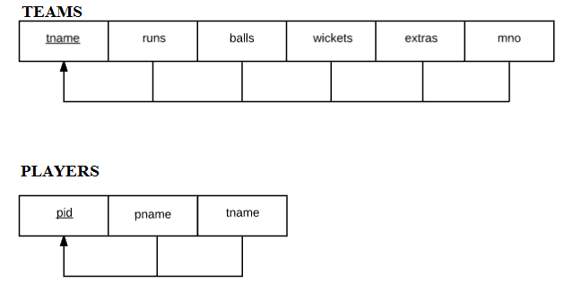

**4.2 Stored Procedure:**

Stored procedure is a procedure written in SQL and other control statement stored in database which can be called by the database engine and connected programming languages.

In this Cricket Scoring system a user can search for old matches and its details which retrieves the information from the database through a stored procedure shown below.

DELIMITER $$

CREATE PROCEDURE `search_matches`

(IN `var` VARCHAR(50), IN `uid` VARCHAR(50))

select m.team_a,m.team_b,m.tournament,m.m_date,m.num_overs,m.toss_won,m.elected,m.venue from matches m,users u where m.team_a=var or m.team_b=var or m.tournament=var or m.venue=var and u.email=uid$$

DELIMITER ;

**4.3 Trigger:-**

The MySQL trigger is a database object that is associated with a table it will be activated when a defined action is executed for the table the trigger can be executed when you run one of the following MySQL statements on the table that is INSERT, UPDATE and DELETE before or after the event.

In this Cricket Scoring System there is a trigger to calculate the strike rate of a batsman, to validate the match date and to restrict the bowler from bowling more than maximum numbers of overs allowed for a bowler.

CREATE TRIGGER `date_trigger` BEFORE INSERT ON `matches`

FOR EACH ROW

BEGIN

IF NEW.m_date < CURRENT_DATE

THEN

SIGNAL SQLSTATE '45000' SET MESSAGE_TEXT = 'WARNING: match date cannot be greater than current date!';

END IF;

END

CREATE TRIGGER `max_overs_per_bowler` BEFORE INSERT ON `bowling`

FOR EACH ROW

BEGIN

IF NEW.balls > 60

THEN

SIGNAL SQLSTATE '45000' SET MESSAGE_TEXT = 'This bowler has exceeded his qouta of overs. Choose another bowler!';

END IF;

END

CREATE TRIGGER `calc_strike_rate` BEFORE INSERT ON `bating`

FOR EACH ROW

BEGIN

SET new.strike_rate = (new.runs / new.balls) * 100;

end

**4.4 Testing :**

The purpose of testing is to discover errors. Testing is the process of trying to discover every conceivable fault or weakness in a work product .It provides a way to check the functionality of components, sub-assemblies and/or a finished product. It is the process of exercising software with the intent of ensuring that a software system meets its requirements and user expectation does not fail in an unacceptable manner. There are various types of test. Each test type addresses a specific testing requirement.

**4.4.1 Types of Testing**

**4.4.1.1 Unit Testing**

Unit testing is a software testing method by which individual units of source code, sets of one or more computer program modules together with associated control data, usage procedures, and operating procedures, are tested to determine whether they are fit for use.

The primary goal of unit testing is to take the smallest piece of testable software in the application, isolate it from the remainder of the code, and determine whether it behaves exactly as you expect. Each unit is tested separately before integrating them into modules to test the interfaces between modules. Unit testing has proven its value in that a large percentage of defects are identified during its use.

**4.4.4.2 Integrated Testing**

Integration testing is a logical extension of unit testing. In its simplest form, two units that have already been tested are combined into a component and the interface between them is tested. A component, in this sense, refers to an integrated aggregate of more than one unit. In a realistic scenario, many units are combined into components, which are in turn aggregated into even larger parts of the program. The idea is to test combinations of pieces and eventually expand the process to test your modules with those of other groups. Eventually all the modules making up a process are tested together. Beyond that, if the program is composed of more than one process, they should be tested in pairs rather than all at once.

**4.4.4.3 System Testing**

The process of performing a variety of tests on a system to explore functionality or to identify problems is called System Testing. System testing is usually required before and after a system is put in place. A series of systematic procedures are referred to while testing is being performed. These procedures tell the tester how the system should perform and where common mistakes may be found. Testers usually try to "break the system" by entering data that may cause the system to malfunction or return incorrect information. For example, a tester may put in a city in a search engine designed to only accept states, to see how the system respond to the incorrect inputs.

**4.4.2 Test Case**

Test case is a set of test inputs, executions and expected results developed for a particular objective.

An excellent test case satisfies the following criteria:

* Reasonable probability of catching errors
* Does interesting things
* Doesn’t do unnecessary things
* Neither too simple nor too complex
* Allows isolation and identification of errors

**4.4.3 Unit Testing**

**User Module**

|  |  |  |  |  |  |  |
| --- | --- | --- | --- | --- | --- | --- |
| **TEST**  **CASE**  **ID** | **TEST**  **CASE**  **NAME** | **TEST CASE DESCRIPTION** | **INPUT** | **EXPECTED RESULT** | **ACTUAL RESULT** | **RESULT** |
| TC 01 | User login | Validate User id and Password | Enter valid User id and Password | User login should be successful | User login successful | PASS |
| TC 02 | User login | Validate User id and Password | Enter  Invalid User id and Password | “Invalid username/password”  Error message should be display | “Invalid username/password” Error message is displayed | PASS |
| TC 03 | User login | Validate User id and Password | If any fields  are left blank | “Fields are empty” Error message should be display | “Fields are empty” Error message is display | PASS |
| TC 04 | Search old matches | Any valid info about match | Enter valid match info | Respective match details are displayed | Search successful | PASS |
| TC 05 | Search old matches | Any valid info about match | Enter  Invalid match info | “no match found for your search” message should be displayed | “no match found for your search” message displayed | PASS |
| TC 06 | Match details | Validate match details | Enter valid match date | Match details should be updated to DB and player details page should be displayed | Match details updated to DB and player details page displayed | PASS |
| TC 07 | Match details | Validate match details | Enter invalid match date | Trigger message “WARNING:match date cannot be lesser than current date” should be displayed | Trigger message “WARNING:match date cannot be lesser than current date” displayed | PASS |
| TC 08 | Select batsmen /bowler | Select exactly 2 /1 batsmen | Check exactly 2/1 check boxes | Update current batsmen/bowler status | Updated current batsmen status | PASS |
| TC 09 | Select batsmen/bowler | Select exactly 2/1 batsmen | Check more than or lesser than 2/1 check boxes | Display  warning message | Display warning  Message | PASS |
| TC 10 | Update score | Runs scored for every ball | Click the runs scored for every ball | Update team, batsmen and bowler scores and display | Updated team, batsmen and bowler scores and display | PASS |

**Table 4.5.6:** whole module Test cases (Unit Testing)

**SNAPSHOTS**

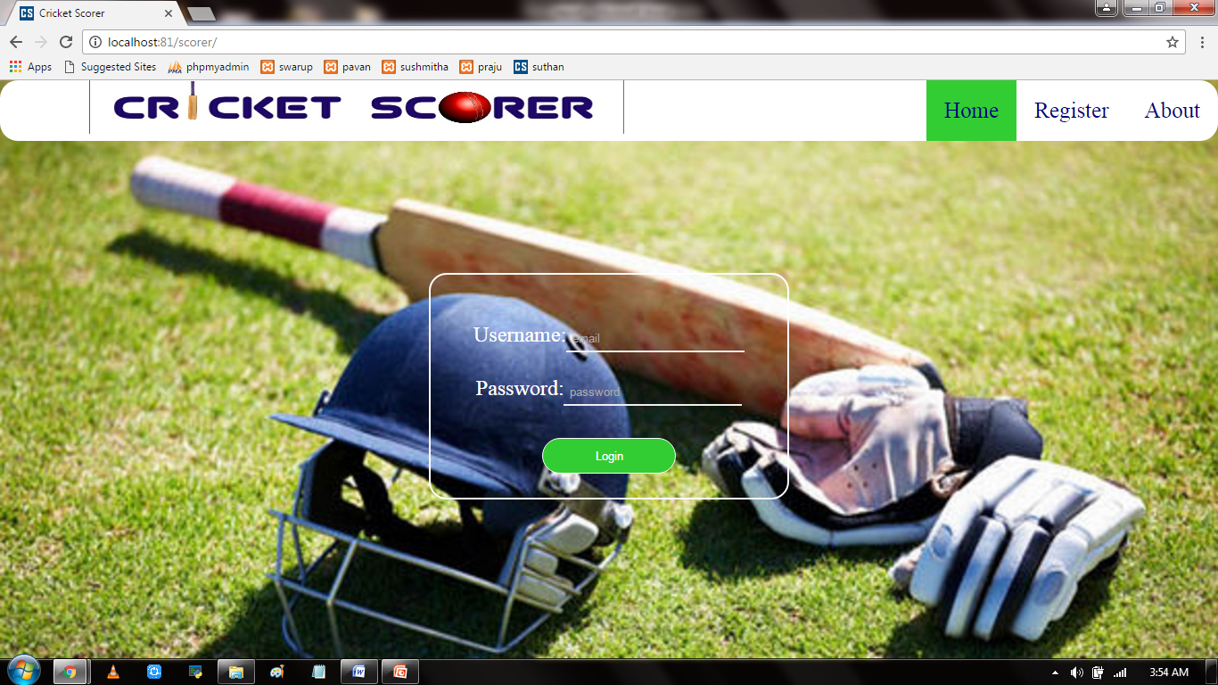

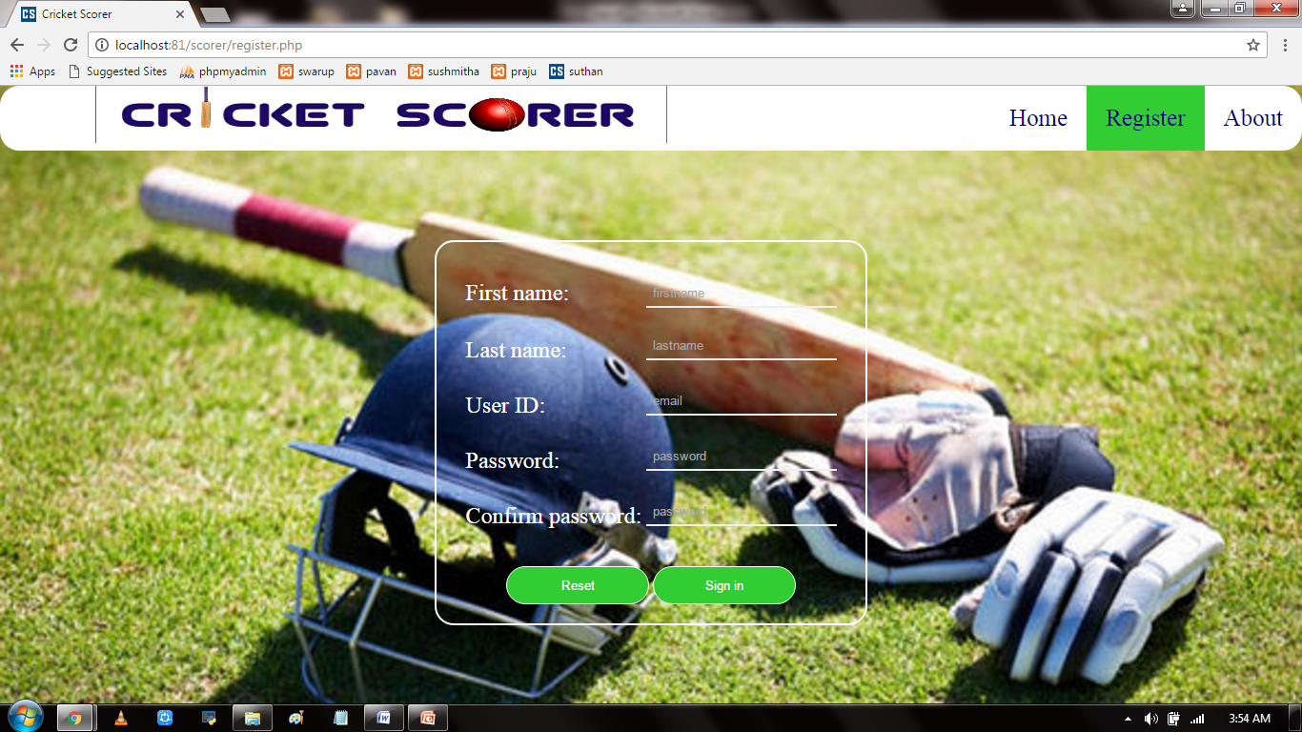

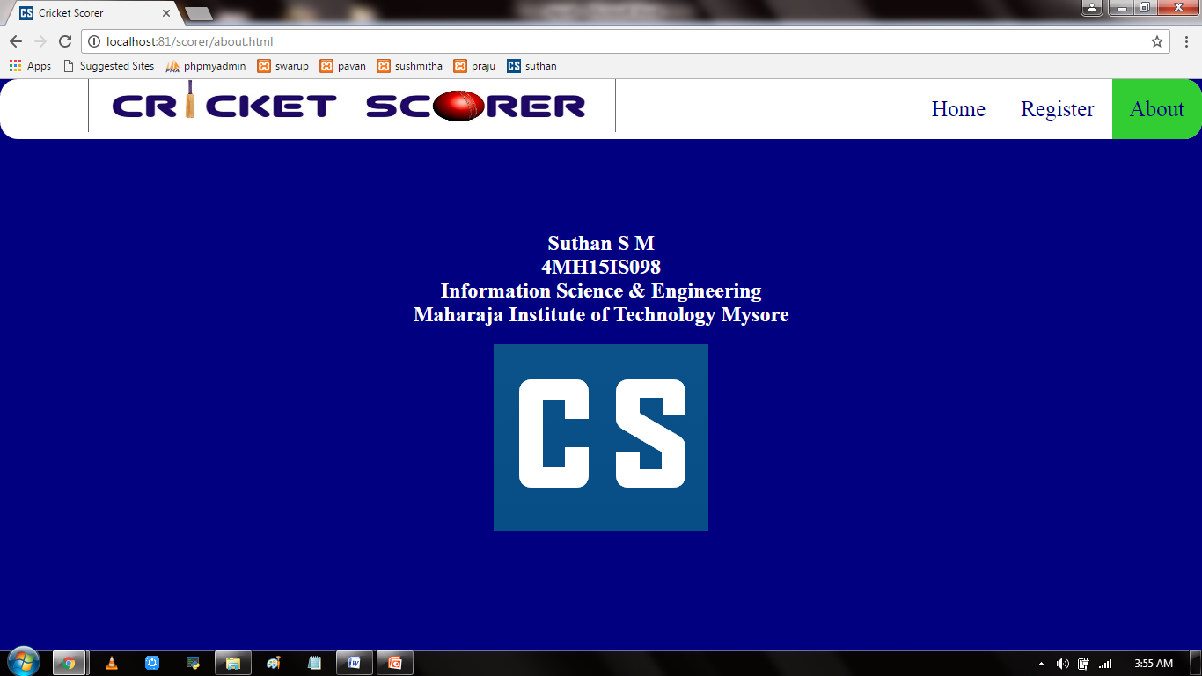

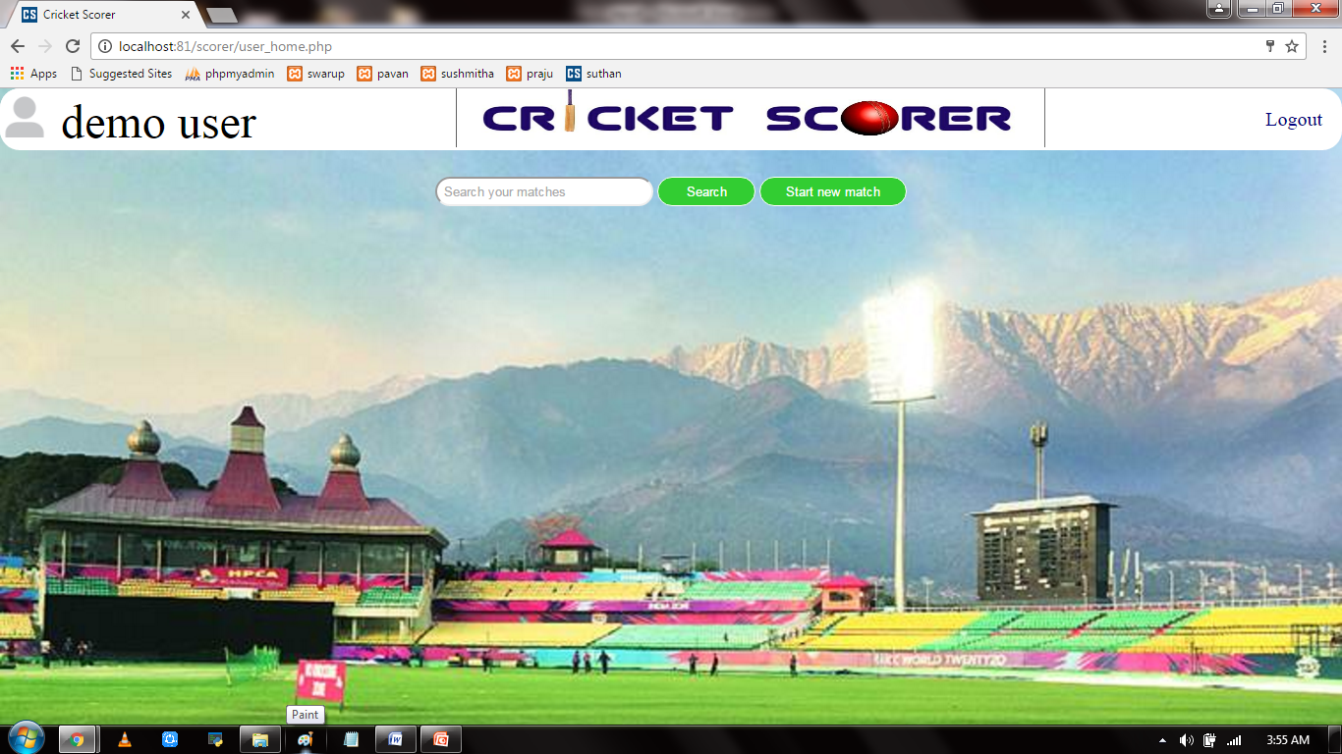

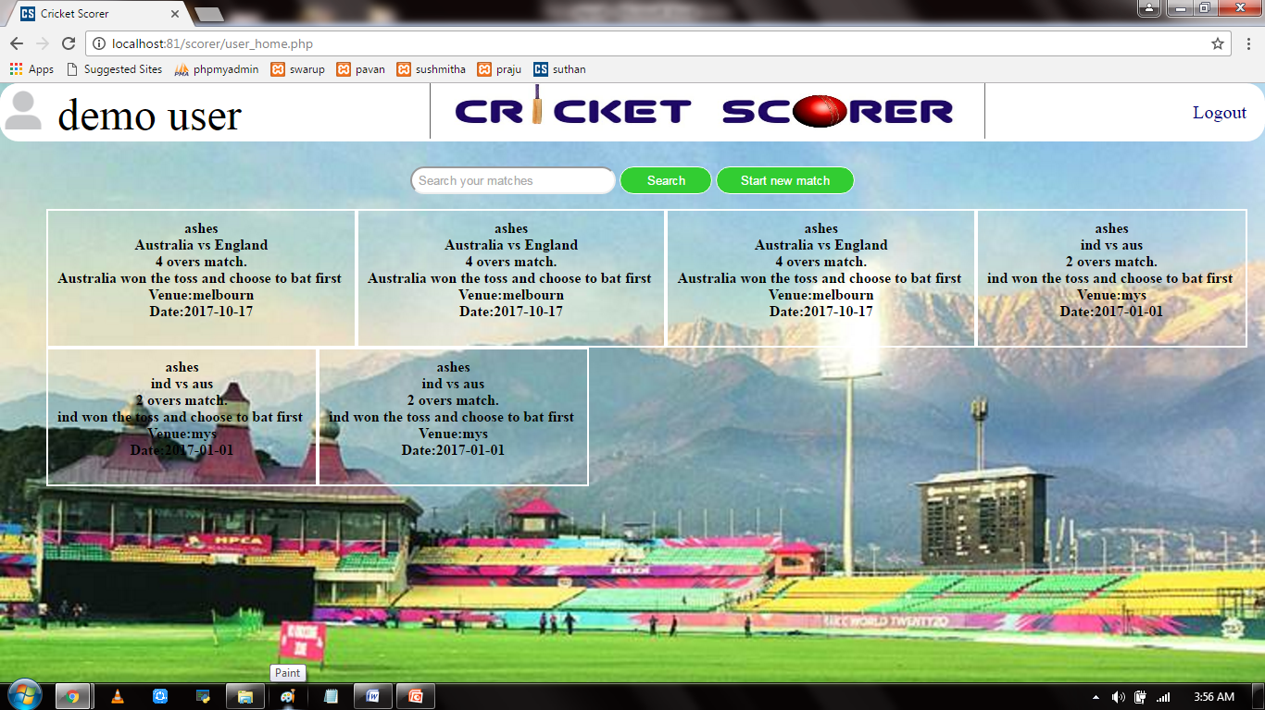

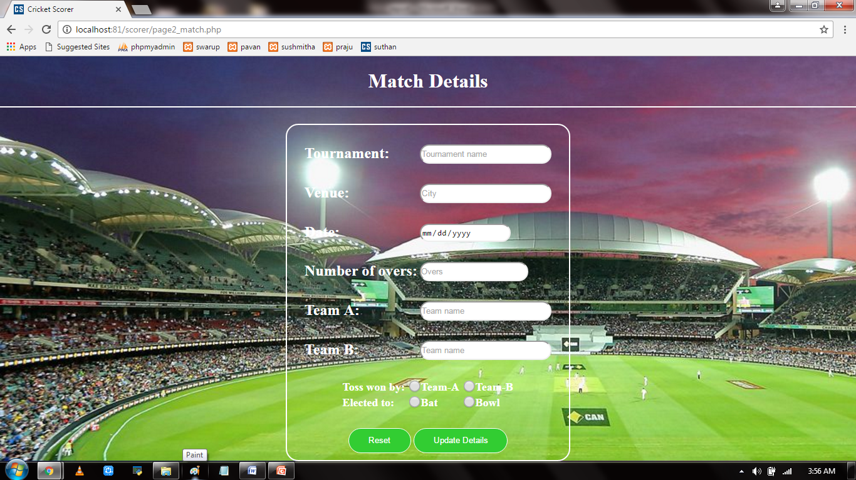

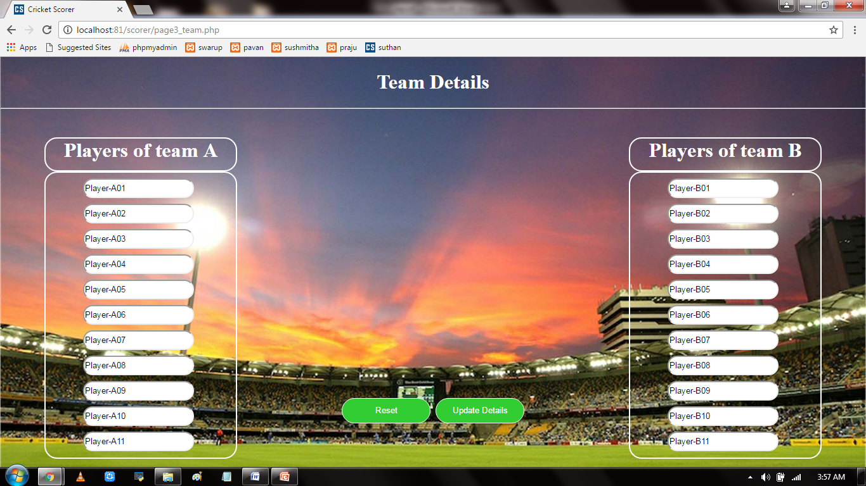

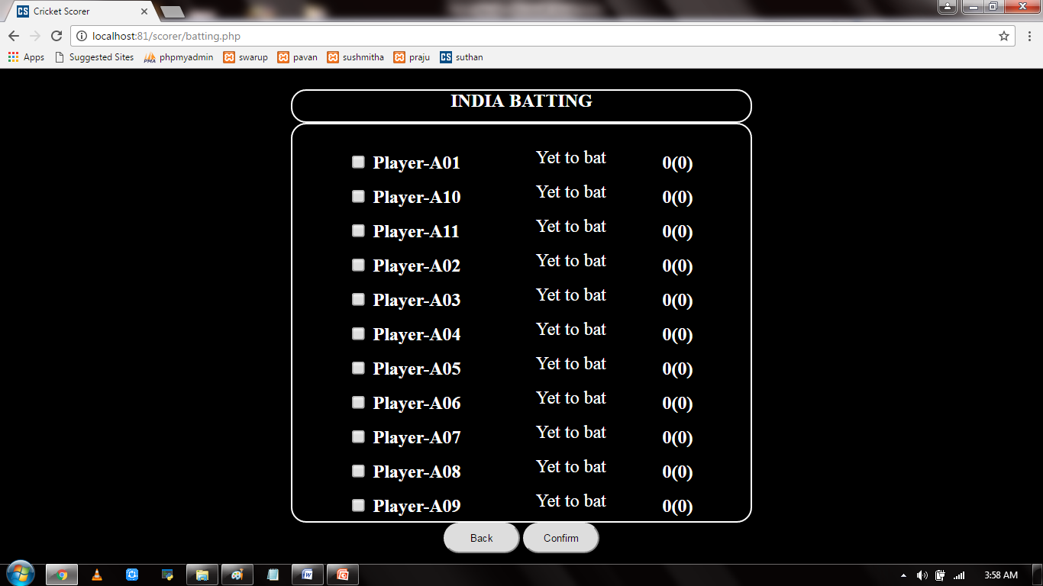

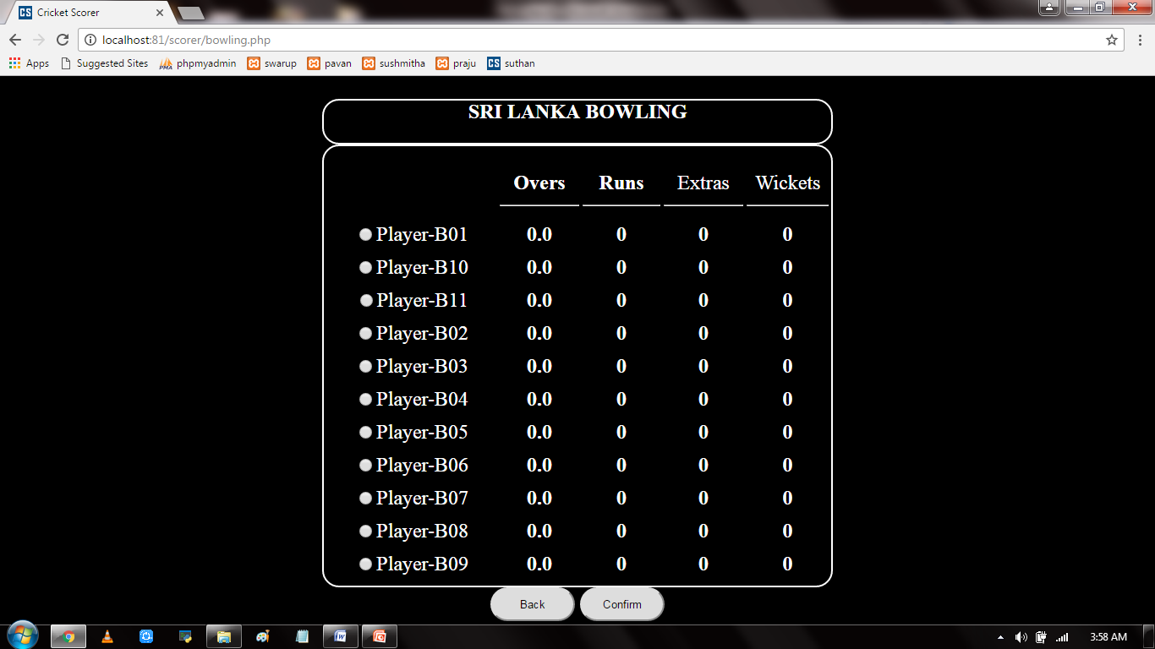

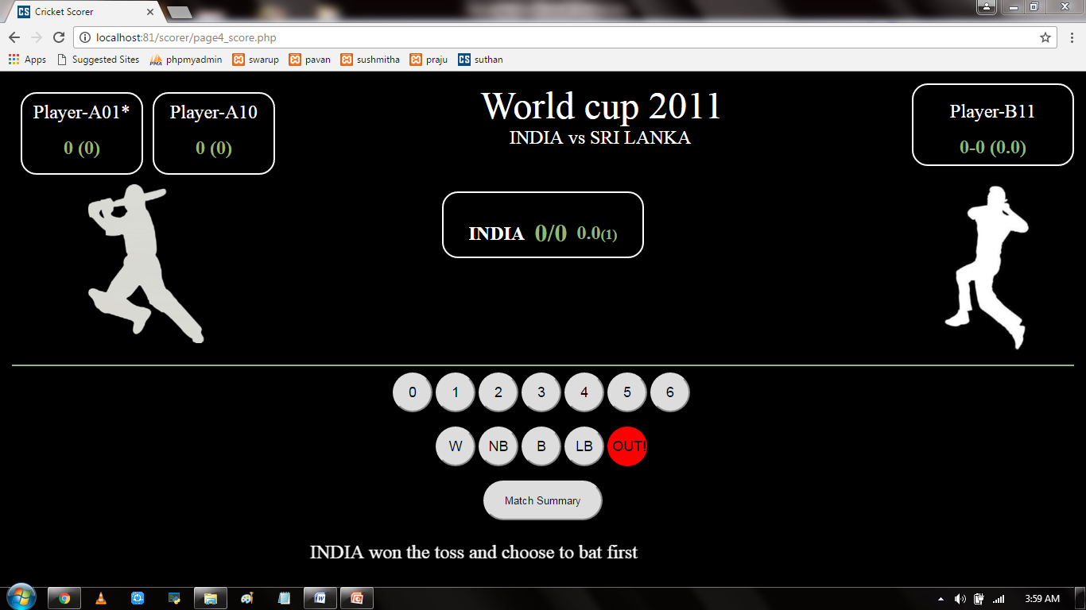

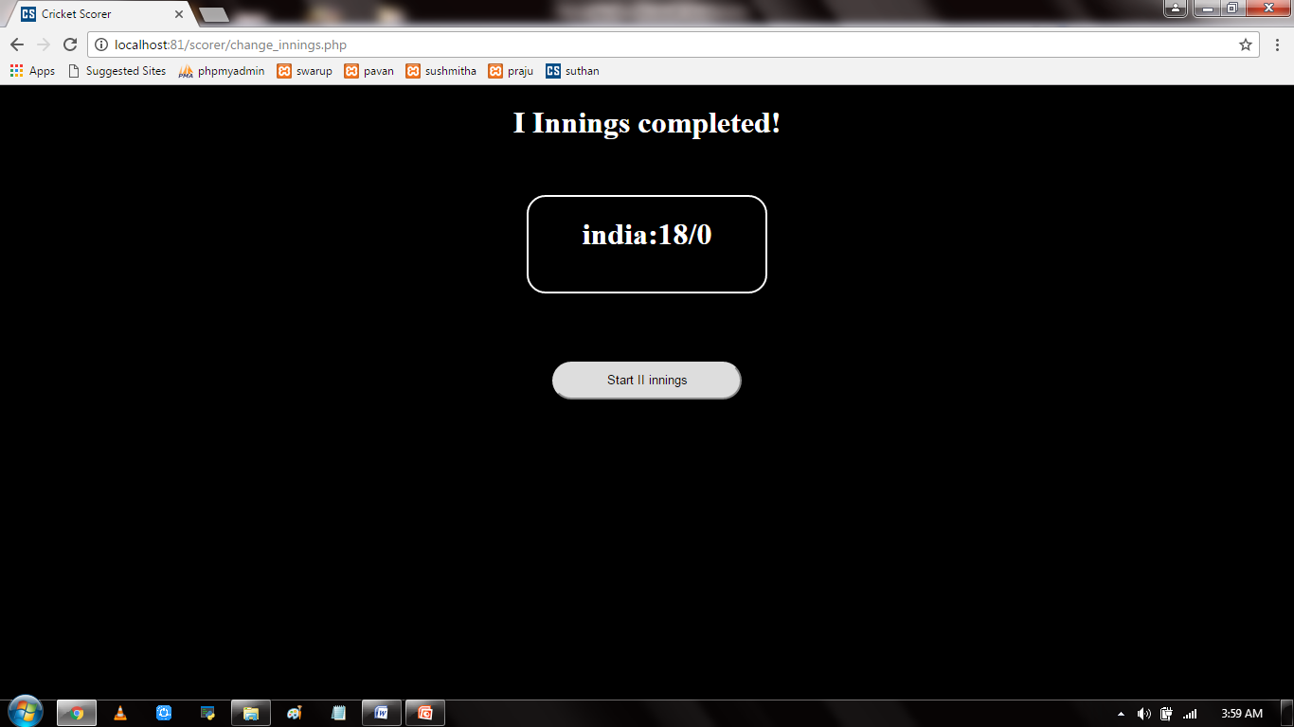

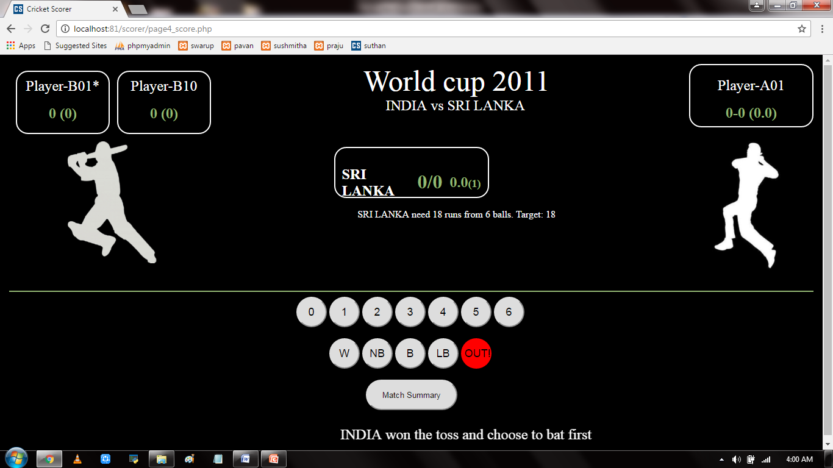

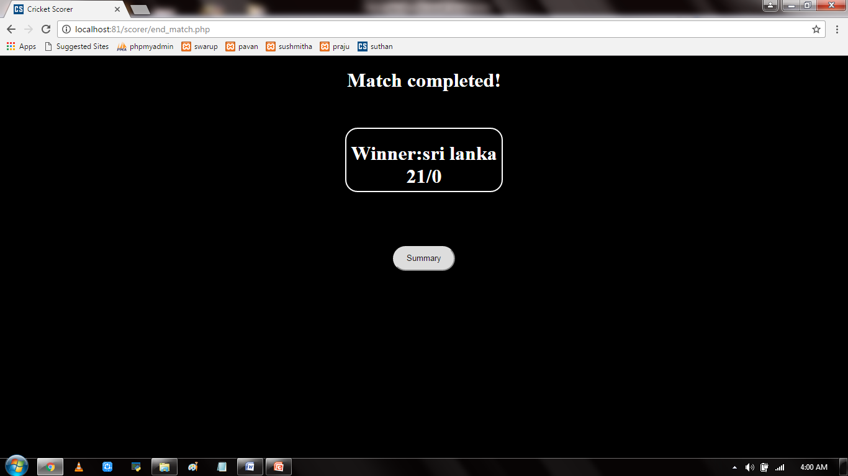

**CONCLUSION**

This scoring web application can be a very useful tool for a cricket scorer who used to put a lots of efforts into updating the scores of team, batsmen and bowler. This application helps the scores update all scores of team, batsmen and bowler in one click of a button. The match details can be documented and the match summary, results and venue and team details of all the old and ongoing matches and the details can be later retrieved by searching the matches based on some information n known about the match. This helps the user to keep track of all the matches he has earlier scored and have a summarized view if those matches. Hence this web application is very useful for a cricket scorer.

**REFERENCE**

* [www.stackoverflow.com](http://www.stackoverflow.com) (StackOverflow)
* [www.w3schools.com](http://www.w3schools.com) (W3 Schools)
* [www.github.com](http://www.github.com) (GitHUB)
* [www.youtube.com](http://www.youtube.com) (YouTube)
* Learning PHP, MySQL & JavaScript – Robin Nixon